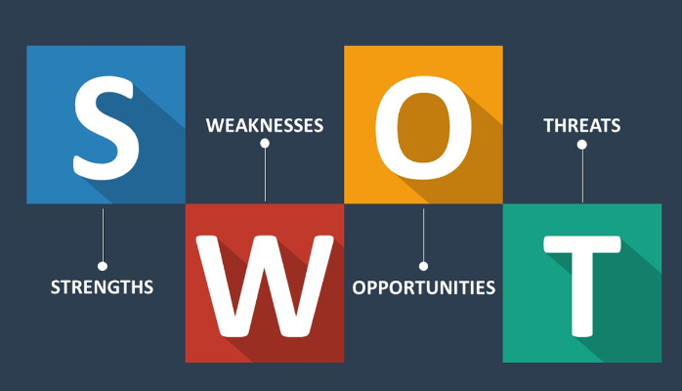

Use the following questions to support you in conducting a self SWOT analysis:

**Strengths (don’t be modest):**

* How do your education, skills, talents, certifications, and connections / networks set you apart from your peers?
* What would your boss or coworkers say are your strengths?
* What resources do you have at your disposal?
* What contributed the most to your past victories?
* What values or ethics do you have that your peers often lack?
* What achievements are you most proud of?

**Weaknesses (be honest):**

* Where are your education, training, or skills lacking? What’s missing and needs improvement?
* What would your boss or coworkers say are your weaknesses or areas of improvement?
* What are your negative work habits and personality traits?  
   What do you avoid because you lack confidence?

**Opportunities:**

* Which opportunities are you not exploiting at the moment?
* What trends are affecting your industry – the industry you belong to or wish to be in?
* In what areas is your industry growing?
* How could new technology help you advance?
* How could your connections and networks help you?

**Threats:**

* What obstacles do you currently face in your career and life?
* Who is your competition?
* Will new technology or certifications demands slow your progress in achieving your goals?
* How is your job or industry changing in ways that could affect your advancement?

S.W.O.T

|  |  |
| --- | --- |
| Strengths     * I am an honest person. I tell people what I am thinking and how I feel. Even if they don’t like what I have to say. * I am a person who can build a good relationship with all around me * My other strength is my family. My mum and my two little brothers, they are my Inspiration who keep me moving and give me the spirit to work even harder | Weaknesses     * My greatest weakness is procrastination. Every time I got a task to do I tend to ignore it until finally when the project near deadlines it’s when I always struggles to get through it |
| Opportunities   * My greatest opportunity at the moment is been given the chance at Akirachix. Of which I am introduced to explore to the world of technology and become an independent woman in the near future. | Threats   * What I fear most is the fear to loose. I hate to be in the state of being a looser. * I also fear the unknown, I tend to fear whatever the outcome of life may be. |